Dissertation dev log
Week 7:
Current Goals for prototype session:
- A working way of profiling the results of the prototype
- A Critical Review of current technology is completed, that highlights where the gap in research is, and the how this project fills it.
- Readme that highlights development roadmap
- A methodology for how the project is going to be researched, and how its going to be evaluated
- Professional, ethical, sustainable, legal, and social review carried out.
- Project is ethically robust
- A plan for security and privacy concerns has been written, and data is well managed.
- Profiling results that are easily replicated and are well documented.
- Project plan with gantt chard
Current Strech goals for prototype:
- Fracture implemented in both OpenGL and Vulkan
- Voronoi clipping implemented
- A way to interact with the fragmented mesh
- An implementation in GLSL, for performance comparison
Completed:
- A working Voronoi fracture in 2D for demonstration
- Working Voronoi fracture in 3D
- Comprehensive background done, covering triangulation, fracturing methods used in games, Graphics API’s, Performance of Graphics API’s, Point sampling, and Voronoi Clipping.
- Clearly stated research question
- Clear, feasible hypothesis, that is well scoped.
- An introduction that provides clear context for the project, and explains the need for the research, including positive impacts and who benefits. It should also highlight the motivation for the project.

Development notes:
This week, I have developed a working prototype of Voronoi fracturing in 3D! This currently still has some visual problems, especially with higher fractures. I suspect this is due to a bad triangulation algorithm being used, and if a proper algorithm is used, it should go away.
I have also done more work on my dissertation, finishing the graphics API section, and completing the triangulation section, and the sampling section, thus finishing my background. The research questions and hypothesis have also been written, with my research question being how does OpenGL compare to vulkan in performance for a 3D Voronoi fracturing of a complex mesh?
And my hypothesis being OpenGL will perform slower than Vulcan at Voronoi cell generation and Voronoi clipping on modern GPU's.
And my Null Hypothesis being OpenGL will be the same speed as Vulkan at Voronoi cell generation and Voronoi clipping on Modern GPU's
Ive also completed my Introduction
A challenge I faced was in upgrading the 2D algorithm to a 3D algorithm. This was solved by thinking of the 3D as 6 2D algorithms done on each face, enabling me to more easily break down the problem.
Resources: 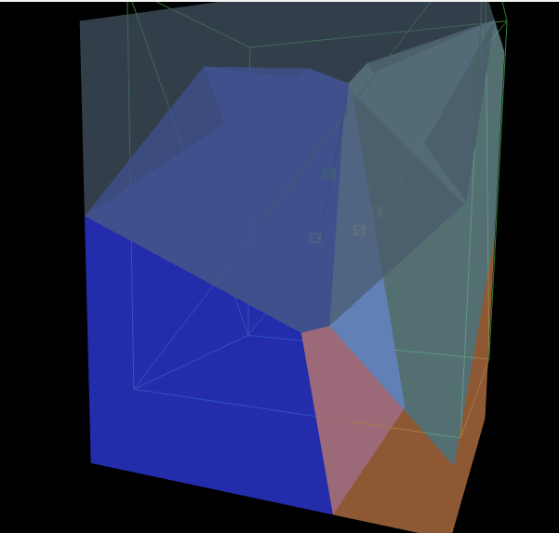
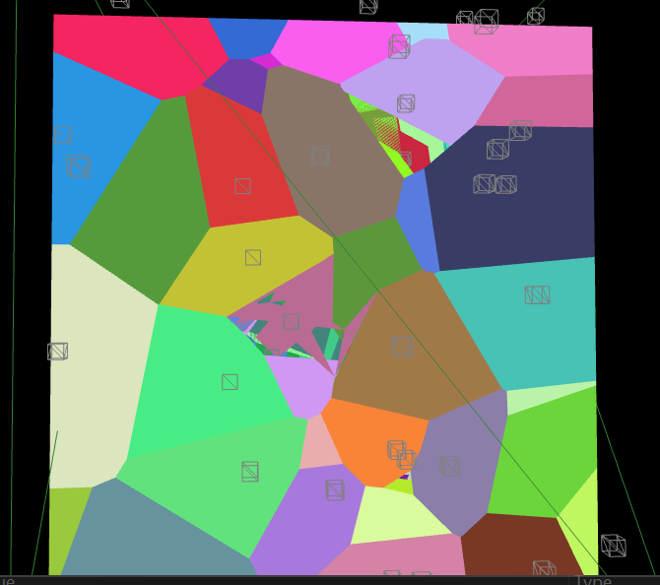
References:

